Airline Ticket Purchase System
System Sequence Diagrams + Activity Diagrams

This document explains two main use cases for my Airline Ticket Purchase System and shows the system sequence diagrams and activity diagrams for each.

Use Case 1: Search Flights + Compare + View Details
Actor: Traveler/User
Objects/Components: Search UI, FlightSearchService, FlightDB
Steps:
1. The user enters From/To cities, date(s), and number of passengers.
2. The system validates inputs (missing city/date, bad date order, etc.).
3. The system searches flights and returns a list of matches.
4. The system shows results with price + estimated total cost (fare + fees).
5. The user applies filters (price, airline, time) and compares flights.
6. The user selects a flight to view details (times, rules, seat map availability).
7. If no flights match, the system shows a “no results” message and lets the user edit the search.
System Sequence Diagram:
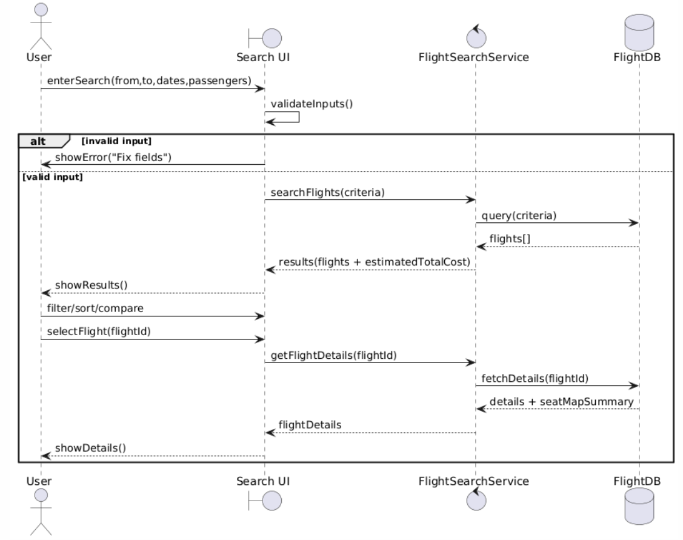
Activity Diagram:
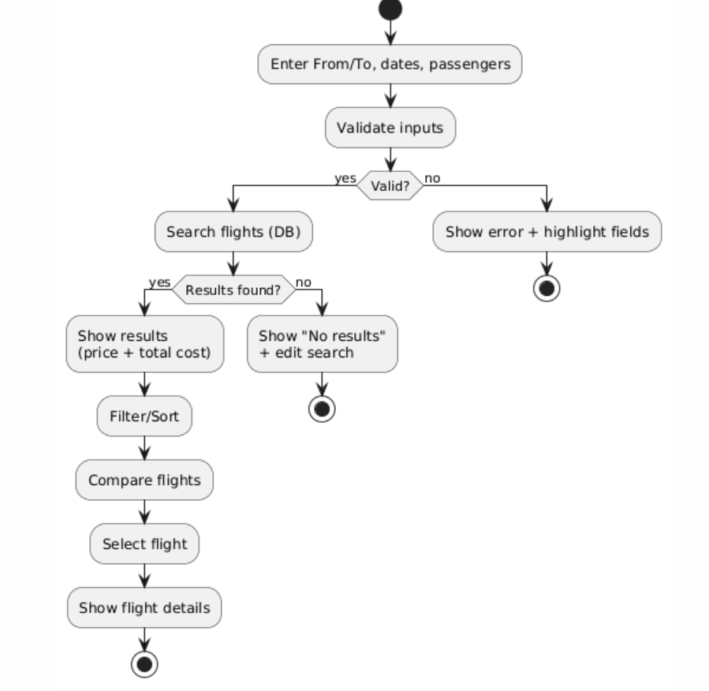
I show total cost early (base fare + taxes/fees) so users don’t get surprised at checkout. Errors are handled with clear messages (no confusing dead ends).

Use Case 2: Book Flight + Seat Selection + Payment + Confirmation
Actor: Traveler/User
Objects/Components: Booking UI, BookingService, SeatService, PaymentService, BookingDB, SeatDB
Steps (interaction):
1. The user picks a flight from results and starts booking.
2. The system shows seat map (or seat choices) and the user selects a seat.
3. The system checks if the seat is still available and temporarily holds it.
4. The user enters passenger info (name, DOB) and contact info.
5. The system calculates final total cost and shows it before payment.
6. The user submits payment (card).
7. The payment service returns approved/declined.
8. If approved: the system creates the booking, issues a ticket/confirmation, and releases the seat hold into a final seat assignment.
9. If declined: the system shows an error and lets the user try again or choose another payment method.
System Sequence Diagram:
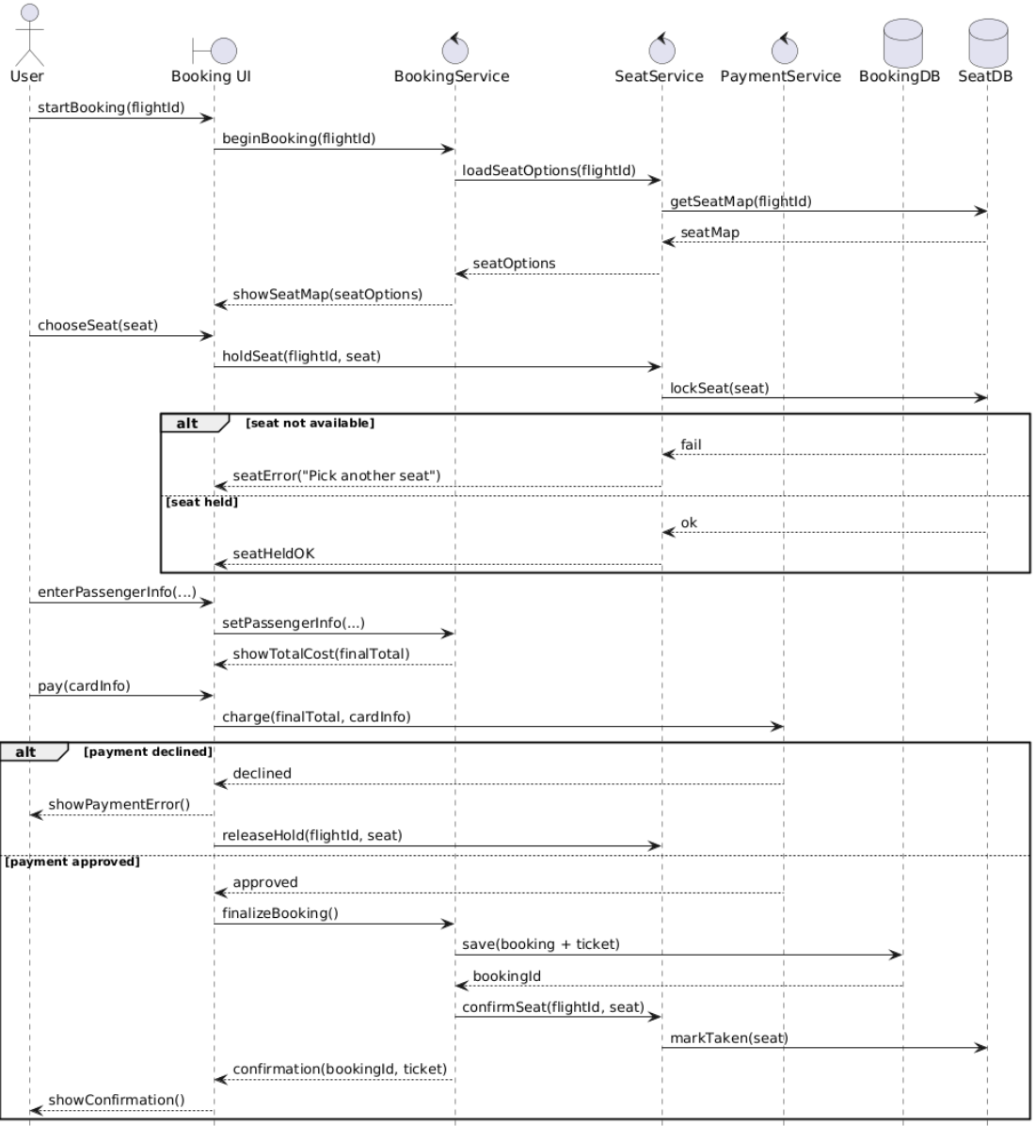
Activity Diagram:
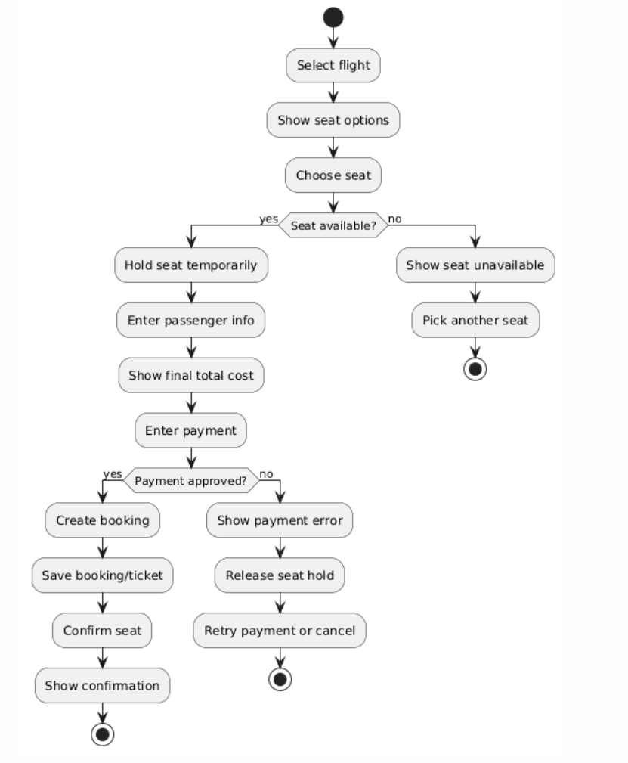
Implementation Approach
For my rough Java implementation, I’m using simple service classes (FlightSearchService, BookingService, PaymentService) and model classes (User, Flight, Booking). Later, these can be moved into a web app (like Spring Boot) but the core flow stays the same.

